Name : Anchal Kumari
Reg. No.: 192312255
Course code: CSA1708
Artificial Intelligence CO-1 AT-1
Analytical Problem Solving

1. Solve the Water Jug problem: you are given 2 jugs, a 4-gallon one and 3-gallon one. Neither has any measuring maker on it. There is a pump that can be used to fill the jugs with water. How can you get exactly 2 gallons of water into 4-gallon jug? Explicit assumptions: A jug can be filled from the pump, water can be poured out of a jug onto the ground, water can be poured from one jug to another and that there are no other measuring devices available.
Sol:
Problem Understanding
There are two jugs:
- Jug A = 4 gallons
- Jug B = 3 gallons
The goal is to obtain exactly 2 gallons in the 4-gallon jug.
Allowed operations:
- Fill any jug.
- Empty any jug.
- Pour water from one jug to another.
Method Selection
Use State Space Search (Breadth-First Search) because every state can be represented as:
$$\left(Amount in 4G Jug , Amount in 3G Jug\right)$$

Solution Process
Step | 4-Gallon | 3-Gallon | Action
1 | 0 | 0 | Start
2 | 0 | 3 | Fill 3-gallon
3 | 3 | 0 | Pour into 4-gallon
4 | 3 | 3 | Fill 3-gallon again
5 | 4 | 2 | Pour into 4-gallon until full
Final State
$$\left(2 , 0\right)$$
Exactly 2 gallons are in the 4-gallon jug.
Accuracy of Calculation
Each operation follows the given rules.
Final amount:
4-gallon jug = 2 gallons
Correct.
Interpretation of Results
The Water Jug problem is solved using state-space search, where each state represents water levels in both jugs. The goal state is successfully reached.

2. Find out how Mars Rover, analyze and explore the samples on Mars by answering the
following questions.
i. What are the percept’s for this agent?
ii. Characterize the operating environment.
iii. What are the actions the agent can take?
iv. How can one evaluate the performance of the agent?
v. What sort of agent architecture do you think is most suitable for this agent?
Why?
Sol:
Problem Understanding
Mars Rover is an autonomous robot that explores Mars, collects samples, analyzes rocks, and sends data back to Earth.
Method Selection
Use the PEAS Model (Performance, Environment, Actuators, Sensors).
Solution Process
i. Precepts
- Camera images
- Rock color
- Soil composition
- Temperature
- Distance to obstacles
- Battery level
- GPS/location
- Weather conditions
ii. Operating Environment
- Partially Observable
- Dynamic
- Sequential
- Continuous
- Unknown
- Real-world environment
iii. Actions
- Move forward/backward
- Turn
iv. Performance Evaluation
Performance is measured by:
- Number of samples collected
- Accuracy of analysis
- Communication success
v. Suitable Agent Architecture
Utility-Based Learning Agent
Reason:
- Learns from previous observations.
- Makes decisions under uncertainty.
Accuracy of Calculation
The PEAS model correctly identifies sensors, actuators, environment, and performance measures.
Interpretation of Results
Mars Rover works as an intelligent autonomous agent capable of sensing, learning, planning, and acting without continuous human control.

3. Explore the search space using search strategies and formulate the problem
components for the 8-Queens problem using the following information: Place 8
queens on a chessboard such that none of the queen’s attack any of the others. A
configuration of 8 queens on the board as shown in the figure below, but this does not
represent a solution as the queen in the first column is on the same diagonal as the
queen in the last column.
Sol:
Problem Understanding
Place 8 queens on an 8×8 chessboard so that:
- No two queens share the same row.
- No two queens share the same column.
- No two queens share the same diagonal.
Method Selection
Use Backtracking Search.
Reason:
- Efficiently removes invalid placements.
- Explores only promising solutions.
Solution Process
Initial State
Empty chessboard. Goal Test
Check:
- Same row
- Same column
- Same diagonal
If conflict occurs:
Backtrack.
Continue until all 8 queens are placed.
Example solution:
Column | Row
1 | 1
2 | 5
3 | 8
4 | 6
5 | 3
6 | 7
7 | 2
8 | 4
(No queens attack each other.)
Accuracy of Calculation
Every placement satisfies:
- Different rows
- Different columns
- Different diagonals
Interpretation of Results
Backtracking efficiently searches the state space and finds a valid arrangement without checking every possible configuration.

4. A customer wants to travel from the one location to another location using OLA Cab
booking mobile application. The customer can select the any of the cab type as mini,
micro, sedan, shared, prime and so on based on his comfort to reach the destination.
Identify what type of problem-solving agent can be used and write the pseudocode
for the above problem.
Problem Understanding
A customer wants to book a cab.
Options include:
- Mini
- Micro
- Sedan
- Prime
- Shared
The system selects the best cab based on user preference.
Method Selection
Use a Goal-Based Problem Solving Agent.
Reason:
The goal is:
Find the best cab that satisfies user requirements.
Solution Process
Pseudocode
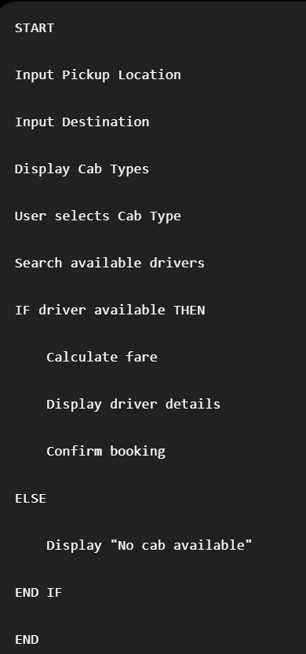
Accuracy of Calculation
The algorithm:
- Accepts user input.
- Finds matching cab.
- Books if available.
Interpretation of Results
The Goal-Based Agent searches available cab options and selects one that achieves the user's objective of reaching the destination comfortably.

5. A logistics company operates a delivery network where packages must be transported
between warehouses at minimum cost. Each route between warehouses has an
associated travel cost (fuel + time). The company wants to determine the least-cost
path from the starting warehouse S to the destination warehouse G using the Uniform
Cost Search (UCS) algorithm.
Sol:
S → A = 1
S → G = 12
A → B = 3
A → C = 1
B → D = 3
C → D = 1
C → G = 2
D → G = 3
Problem Understanding
The logistics company wants to transport packages from warehouse S to warehouse G at the minimum travel cost.
Since every route has a travel cost, the task is to find the least-cost path.
Method Selection
Use Uniform Cost Search (UCS) because:
- Edge costs are different (weighted graph).
- UCS always expands the node with the lowest cumulative cost.
- It guarantees the optimal (minimum-cost) path.
Solution Process
Step 1
Start at S
Priority Queue:
S = 0
Step 2
Expand S
Possible paths:
A = 1
G = 12
Queue
A(1)
G(12)

Step 3
Expand A
New paths
B = 1 + 3 = 4
C = 1 + 1 = 2
Queue
C(2)
B(4)
G(12)
Step 4
Expand C
New paths
D = 2 + 1 = 3
G = 2 + 2 = 4
Queue
D(3)
B(4)
G(4)
G(12)

Step 5
Expand D
New path
G = 3 + 3 = 6
Queue
B(4)
G(4)
G(6)
G(12)
Step 6
Expand B
D = 4 + 3 = 7
Current best path remains unchanged.
Step 7
Next lowest-cost goal node is:
G = 4
Search stops.
Shortest Path
S → A → C → G
Total Cost
S → A = 1
A → C = 1
C → G = 2
Total Cost = 1 + 1 + 2 = 4
Accuracy of Calculation
Path | Cost
S → G | 12
S → A → B → D → G | 1+3+3+3 = 10
S → A → C → D → G | 1+1+1+3 = 6
S → A → C → G | 1+1+2 = 4
The minimum cost is 4, so UCS correctly finds the optimal route.
Interpretation of Results
Uniform Cost Search successfully identifies the least-cost delivery route:
S → A → C → G
with a minimum total travel cost of 4. This ensures the logistics company minimizes fuel and travel expenses while guaranteeing the optimal path.

